Daniel Reid Nelsen

CS 372 Introduction to Networking

Client-Server Chat/Game – Portfolio Assignment

12/7/2023

**Introduction**

This program is run by running two separate files: server.py and client.py. To start the program run the following command in two separate terminals. The server must be started first and then the client. The port can be configured in the files, but must be the same port in both files. The IP address is currently set to 127.0.0.1, but is also configurable in each of the files. Using /q will cause command on either the server or client will cause both sides of the program to shut down.

Once the server and client are connected, the client is able to start a trivia game where the server will ask the client random questions from a list of about 5,500 trivia questions. The game is started using /game. To end the game by enter /endgame. At the end of the game the server will send the score. During the game portion of the chat an object is created from the triviagame.py file. The trivia_questions.json file holds all the questions and is accessed and read when the game object is generated.

Assumptions: There is no error handling in either the client or server programs. Therefore, entering data in either side of the chat must be done correctly at all times.

Sources:

Code for the chat server was adapted from

The Simplest Python Chat You Can Build

https://www.youtube.com/watch?v=Ar94t2XhKzM

Accessed 12/2/2023

Trivia questions were adapted from Open-trivia-database on Github.

<https://github.com/el-cms/Open-trivia-database>.

Accessed 12/2/2023

This database has about 50,000 questions, but I’m only using a subset.

**Execution of program**

*On Windows*

Server: python.exe server.py

Client: python.exe client.py

*Screenshots of client and server running*

Client

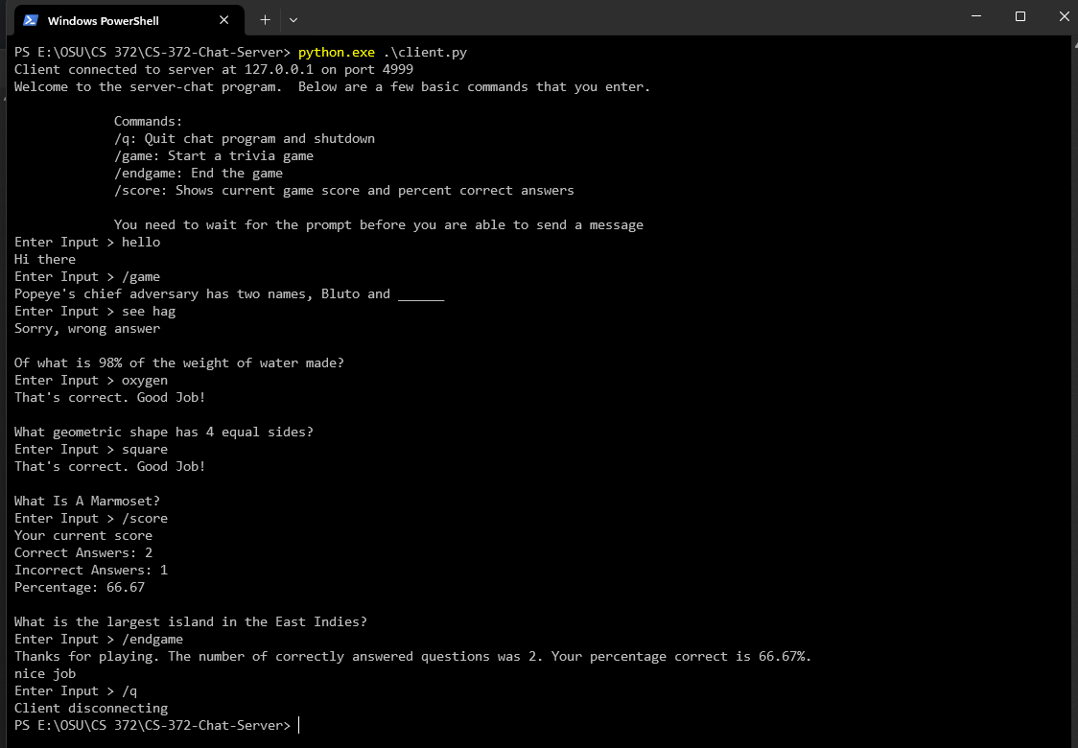

Server

